Odyssey Rochester Review: Top 8
Zvi Mowshowitz
Monday, January 28, 2002
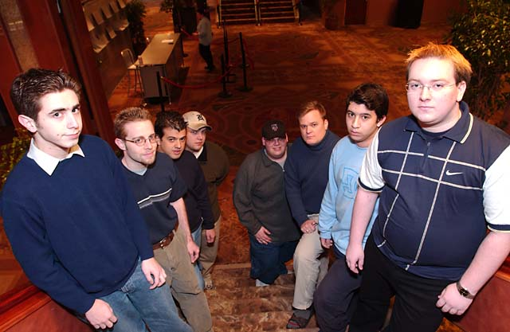
The drafters
Normally the story of a draft begins with the first card. In the case of the final draft of Pro Tour-San Diego, the story begins a bit earlier. Whatever the draft format, at tables full of good drafters it's vital that players be flexible. In any given draft, the cards will favor some strategies over others in any given seat, and a player who isn't prepared to draft what he needs to draft faces disaster. Such a player might get away with such a gamble for a while, but over five drafts it will almost certainly catch up to them. Last year, the player dedicated to a single color combination was Ekebom. He'd gotten through the tournament drafting nothing but blue-black, and he continued following this strategy in the Top 8. The resulting position was less than stellar, but Ekebom felt that the combination was so strong that it was worth forcing regardless.
This time, the dedicated black-blue drafter was Jeff Cunningham, and the new twist was that he was in first place after the Swiss. Some people would point to the fact that such an inflexible drafter made it to the final day twice in a row as evidence that it's a good strategy, but I would say that it simply means that it's possible for someone following such a strategy to get lucky for four drafts. Eventually, the table will break wrong. At any rate, Cunningham had earned the right to decide where the draft would start. All Rochester positions are not created equal, so this can be a distinct advantage. Most people consider the best position to be seat 4. You get to watch everyone on your right set up, you get worthwhile cards from the start, you have a decent amount of control in the draft. All the middle positions are fine for similar reasons. By far the worst seat is Seat 1, because you have to use a first pick before you learn anything about the person on your right. After that come the very late positions, which are often at the mercy of the draft but at least don't have to give up any picks to conform to what the table says they need to be drafting. The conventional wisdom is to put yourself in Seat 5, since that puts your first round opponent in Seat 1, and if I got to place the marker that's what I would do.
Jeff Cunningham had something different on his mind. Cunningham's goal was to find the position from which he was most likely to get a good seat from which to draft black-blue. I understood his reasoning immediately when I heard what his decision had been. Most pros prefer blue, but they also know better than to fight with the player on their right for it. That means that in the majority of tables, seat 1 will take a blue, white or black card to start the draft, and seat 2 will take a green or red one. That would leave Cunningham free to pursue his deck of choice. On the other side of the table, his opponent would be stuck in seat 7, which is mediocre. It made perfect sense, and if I really felt that a color combination was that strong, I might well have done the same thing.
It didn't work. For those who want to follow in detail, the packs are available here. There were two people ahead of Cunningham, and both of them got in the way. Jens Thoren's job was to play a blue deck, ideally blue-white but it's fair to assume that anyone who always drafts blue-black wasn't about to get picky. Instead, there was no especially strong blue card in the first pack, and he chose to draft Rabid Elephant.
Oops.
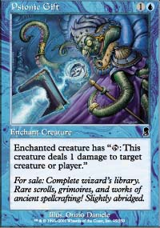
In seat 2 was Donnie Gallitz, and his plan was to draft blue-white. To him, this pick must have seemed ideal. He then had to choose between two blue cards, Aven Fisher and Psionic Gift. Knowing that he was going to be drafting blue-white, he took the Psionic Gift. Like Gallitz, I tried to draft white-blue when I could, but there's no question in my mind I would have taken Aven Fisher. Aven Fisher is clearly the stronger card overall, and in my opinion flyers are too important to take the Psionic Gift this early, even if you know you're drafting blue-white. It's most likely that Gallitz simply disagreed with that, but the other advantage of taking the Gift is that it's a very clear signal to good players that he intends to draft blue-white. The Aven Fisher only signals blue. Of course, if he knows that Cunningham is going to draft blue-black no matter what, and it was pretty much common knowledge at that point, it doesn't make any difference if he signals white - he's probably drafting white whether he likes it or not. Indeed, by making blue-black a less attractive combination to Cunningham, the Aven Fisher is probably the better pick in terms of table manipulation. Instead of getting a solid creature for his deck, if he stays in color Cunningham only gets a mediocre at best (for black-blue) Psionic Gift and he has to worry about Gallitz going black-blue himself. A less dedicated player would take the easy way out and draft a green deck.
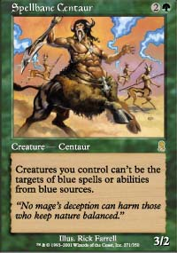
Cunningham then stuck to his guns, taking the Aven Fisher, which meant that Farid Meraghni was going to be drafting green, most likely green-red since Gallitz and Cunningham were probably drafting white and black respectively. He chose to take Spellbane Centaur over Chainflinger, and I agree with that. Eric Froehlich's position was then clearly best suited to white-blue, and he took Scrivener. Frederico Bastos took Chainflinger next. Andrew Wolf now has to figure out what is going to happen to Bastos' draft. He's behind a blue mage, probably blue-white, and he's drafting red. The two choices that make sense for him therefore are black and green. If he takes black, there will almost certainly be three or less black drafters, three or less red drafters and no one else drafting both, so if Bastos is comfortable in black-red, that's a solid option. His other option is to become the tables' third green mage, quite likely one of four. Both choices make sense, although green is more likely. Andrew Wolf took Krosan Archer, hoping that by going green now he could convince Bastos to choose black. Neil Reeves filled in the remaining gap in the table with Dusk Imp and Laquatus's Creativity. With two players already drafting blue-white, there was no way he could draft white without either going into the questionable black-white or fighting two other players for the same color combination. That left black-blue as the clear choice. Before I go on, I'd like to make a quick aside: Laquatus's Creativity is not as unplayable as people think it is. I sideboarded it in during round 13, and it served me well.
The second pack illustrated what value different players put on flexibility. Gallitz's best pick is clearly Aven Smokeweaver, and I can't argue with Dusk Imp for Cunningham either. There's no new information there, since he was black-blue from before pack one. Froehlich had little choice but to take Second Thoughts, which was fine but would go on to cause problems later on. Bastos got to declare he was black-red, and Wolf settled into red-green.
In pack three, Meraghni had a choice to make between Firebolt and Werebear. This is a question of commitment. He's already green, and it looks like he should be red, but is he willing to take the clearly superior Firebolt over Werebear? That only makes sense if his color situation is completely up in the air. If nothing else, he's about to get a second pick and a first pick, so there's something to be said for staying on the lookout for bombs of any color. My opinion however is that Firebolt is more than good enough to make that choice. The last remaining question is what impact this will have on the other drafters, but with Wolf already red-green and Bastos already showing black-red, it seems unlikely that passing a Werebear would change anything. In short, I think Meaghni gave up a Firebolt for no good reason - even if he thinks there's a decent chance he abandons it right away due to opening a bomb, and I don't think he should for anything but a few select rares. The rest of the picks were easy, and pack four locked Meaghni into red with a Kamahl. Froehlich got a Kirtar's Desire, which meant that although his deck's card quality was doing fine he had to be starting to get worried about his overly defensive cardpool and lack of win conditions.
Pack five again asks a player to balance the issue of position at the table with what he wants for his deck: Eric Froehlich had to choose between another Second Thoughts to cut off white or the blue Repel, which was clearly better for his deck at this stage. Second Thoughts is often easy to play around when there are multiples, especially in Rochester, and not only is the second one not as good as the first, it renders any additional copies virtually useless. This early in the draft, that has to be a major consideration. However, there's no question that if Second Thoughts would create a white drafter then it's far more important than picking up a Repel. Who's going to take it? I think it's clear that Bastos and Wolf aren't going to touch it, and Jens Thoren would be more interested in a Patrol Hound than a Second Thoughts for a white-green deck. The only real candidate is Neil Reeves. If Dirty Wererat goes to Bastos and the Millikin goes to Wolf, then it's likely Reeves will end up with the Second Thoughts, but I think it's safe to say that the Overrun isn't getting that far. In short, taking the Repel was a safe play.
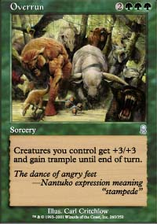
Moving on to Bastos, he had to make a big decision as he was looking at Overrun. If he passes the Overrun to Wolf, that's the foundation for a beautiful friendship, and Bastos still gets a Dirty Wererat for his deck. If he takes the Overrun, in order to play it, he'll have to abandon a color and probably go to war with Wolf, but he gets one of the set's biggest bombs. At this time, there are only three green mages at the table. Given that fact, despite the high value I place on position, I can't fault Bastos for his decision. Overrun is Overrun. As a result of that decision, it looked for a while like Wolf's draft would be in disarray, and his position had certainly gone from average to poor. Bastos' selection of Barbarian Lunatic over Ghastly Demise in pack 6 was a clear indication that he intended to abandon black in order to play the Overrun. That left Wolf to try and do something about the situation.
Wolf started by taking that Ghastly Demise. He had missed his chance to react immediately to the switch in the previous pack with the Dirty Wererat that from his point of view should have gone to Bastos, but Bastos' decision must have taken a few seconds to process and it was probably unclear which color was going to be abandoned. Bastos was about to get a first pick, and opening a broken black card could certainly have changed everything. Now the situation was clear, and the commentators thought that Wolf was making a wise decision to take up the black-red deck abandoned by Bastos. Looking more closely at the pack in question, I have to disagree. I don't disagree with the pick, there's little question it was correct, but I don't think this pick said anything about Wolf's draft. There's nothing in the pack that I would main deck in green-red, so taking the Demise to get the option to splash or switch should something happen seems more important to me than taking a Dwarven Grunt or Moment's Peace for the sideboard.
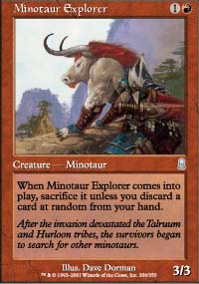
The next pack offered him a choice between Minotaur Explorer and Elephant Ambush. In my opinion, the Explorer is the better card for green-red, so the choice is easy. Wolf disagreed and took the Ambush. What strikes me about this pick is that it totally abandons Wolf's flexibility. Before, he had a few green cards but it was far from impossible for him to switch over to black. Now he's passed up a fine red card for a card with two green mana in its casting cost, and it's unlikely he will be able to get out. He's in position seven, so his next first pick is only three packs away. It's also very unlikely that he'll get Bastos to abandon the Overrun at this point. All that can be said is that no matter how much better I may think I understand Odyssey Rochester than those sitting up at the final table, they were sitting up at the final table and I was back in 35th. Also don't underestimate the impact of fatigue. Rochester Drafting at a high level takes a lot out of its participants. Something that seems clear to me upon detailed analysis is a lot harder to figure out in the heat of the moment.
Later in that pack, what should have been the last decision on what colors to draft was made when Jens Thoren took a Hallowed Healer to become white-green. Gallitz then dealt yet another blow to Cunningham by taking away Patriarch's Desire instead of Patrol Hound. This was not a frustration pick, it was for a splash, and it served Gallitz well. I may not be a big fan of splashing in blue-white but many other people disagree, and Patriarch's Desire is one of the better cards for the deck to splash for.
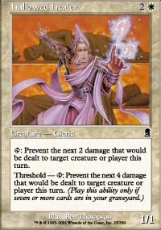
At this point, the structure of the draft was in place. All eight players settled down to draft their decks, and the rest of the draft was just about individual card choices. I'll therefore mention the picks I disagree with that stand out. The first one came in the very next pack as Jens Thoren's picked Stone-Tongue Basilisk over Werebear. Even if you like the Basilisk more than I do, keep in mind Froehlich's two Second Thoughts. In pack twelve, Eric Froehlich took Hallowed Healer over Aven Windreader. It's a difference in deck philosophy, but I think that is flat out wrong. It's more important to get good offense than to stock up on Healers, and at this point in the draft I would actually be pushing the no flyers panic button.
In pack thirteen, Meraghni took a Cephalid Looter first pick and went on to splash blue to play it. While he may have had a Kamahl and Savage Firecat to cycle to, I can't understand either the decision to draft the Looter or the decision to splash it once he had it. His deck was looking very strong, probably the best at the table, and was in no need of a splash. With double red spells and green mana acceleration, why take the huge risk of adding islands to the deck? The fact that he won anyway just shows how powerful his deck was. Andy Wolf took a Chainflinger over a Muscle Burst a few packs later, again showing disregard for speed. I also just find that players aren't giving Muscle Burst any respect anymore, and I have no idea why.
There were two more major mistakes. Eric Froehlich took Shadowmage Infiltrator over Mystic Zealot in a deck that I felt needed a Zealot more than anything but shouldn't have had to splash. Froehlich stands by the decision that Infiltrator is better than Zealot for him, but agrees that it was a mistake because the Zealot clearly then ends up with his first round opponent Thoren, who otherwise would get nothing from the pack. Finally, Bastos took Krosan Beast over just about everything when his final pack came around. When reached for comment, Bastos said that "I really like Krosan Beast." He did have a Millikin in his deck, but I think this one was a little ridiculous.
To sum up the draft, it was all about positioning. While there were some odd individual picks, the draft was won and lost based on the ability of the players to set themselves up. Jens Thoren reached the finals because he realized that he needed to 'take over' Gallitz' white position to have a chance, despite that making him draft white-green. Cunningham lost in the quarterfinals because he was inflexible, and that decision caused the ripple effects that handed the best deck to Meraghni. The only player I felt really got cheated was Neil Reeves. In his position, I might well have done exactly what he did, and I certainly would have been close, and the switch by Bastos made his position even better. Instead of being rewarded for his position, the cards punished him, and there was nothing he could do.
Compare the key decisions in this draft to the key decisions in last year's Top 8 draft. Last year, the draft was about who was able to draft three colors and who could switch in and out of colors to take advantage of the cards, and Mike Pustilnik won due to his unique ability to take and play a few important cards, especially a Probe. This time, the draft came down to setting up early and adopting to the picks of the other players. Positioning was king, and second to it was a few individual picks that weakened several of the decks. Meraghni won this draft before the first pack was opened, as Gallitz and Cunningham went in determined to fight it out over the blue cards and a Savage Firecat and Kamahl, Pit Fighter sat in their packs waiting to join Meraghni's army. When the bombs go off, make sure you're in the right place.

